What Does an Architect Do?
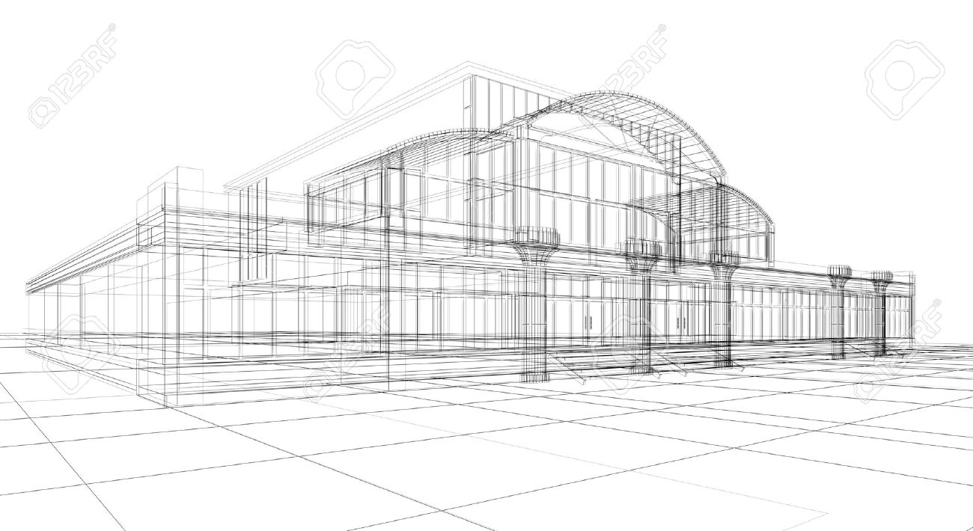

Architects design all kinds of buildings. They design schools and skyscrapers. They design hospitals and hotels. They also design churches, train stations and plain old regular houses.
Any building that is used by people was probably designed by some architect.
Okay then, but what does the word "design" mean? A design is simply a plan. Before constructing a building, an architect needs to draw a plan of the building. Sometimes architects will make a cardboard or plastic model of the building.
The building is then built by a construction company which follows the directions of the plans for the building. The architect will closely supervise the construction company to make sure that the building is built according to the plans.
Okay then, but but what does an architect do when he or she draws up a plan?
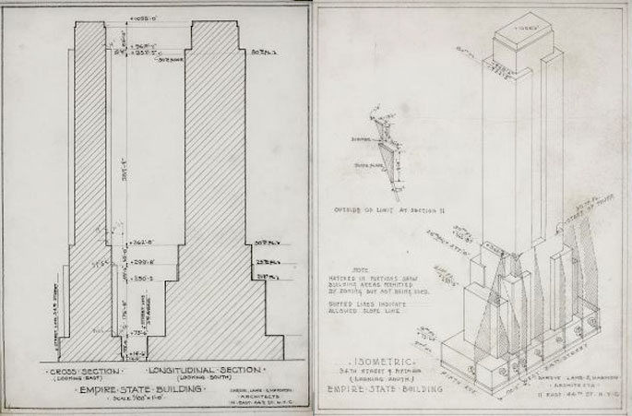
Architects have to thnk of many things before they draw up the plans for a building. First they have to think about what the building will be used for. How many people are going to use the building at the same time? What types of activities will these people do in the building?
An office building will need lots of small rooms for offices. A school will need many medium-sized rooms for classrooms. And a train station will need one larger room for hundreds of people to pass thru at the same time.
All of these building must be built so that they can be used efficiently by everyone who walks through their doors. When architects discuss what the building will be used for, they talk abut the "function" of the building.
But the function of a building is just one of many things an architect has to think about when designing a building. Good architects also spend a lot of time making sure a building is safely designed, and making sure the building will last for many years.
A building that is not safely designed could catch on fire or fall down on itself.
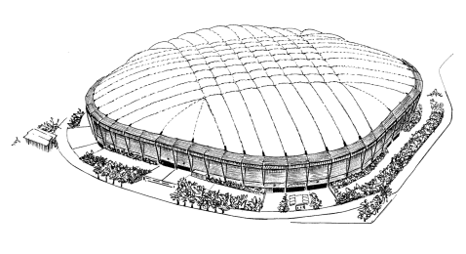
Architects have to design building so that people can escape from the building in an emergency. Of course, some emergencies, such as earthquakes or tornadoes, destroy even the safest buildings.
A few years ago an architect had a real surprise when one of the buildings he designed collapsed under the weight of a foot of wet snow. The building was a sports arena with a large, curved roof. The heavy snow put so much pressure on the roof that the roof collapsed. Luckily nobody was in the sports arena at the time.
Besides thinking about the function and safety of a building, architecs also spend time creatively thinking about how they want the building to look. Just as a painter decides which paints to put where in a painting, an architect decides where to put the rooms, walls, and open spaces in a building.
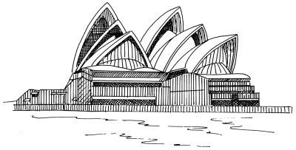
Just as different painters have different styles of painting, different architects have different styles of designing. One architect might like to use a lot of circles and curves in his or her buildings. Another architect might like to design buildings that look sleek and flat.
So architects have to be good artists and good scientists when they design a building. The building must be pleasant to look at, pleasant to work in and strong enough to be safe from most natural disasters.
Trying to do all these things at the same time is part of the challenge and excitement of being an architect.
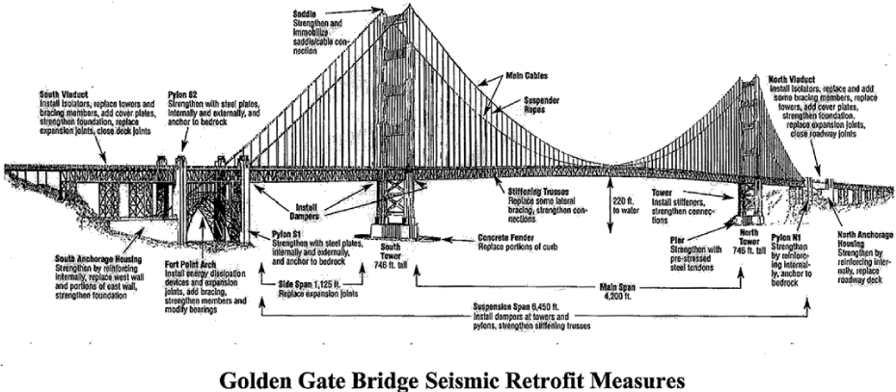

Name____________________
What are three things that an architect has to think about in order to draw up plans for a new building? Use at least 3 examples from the text to support your answer.

Plan
First thing__________________________________
Second thing__________________________________
Third thing__________________________________

Put it in paragraph form.
Use ACE (Answer, Cite, Explain) format to help you organize your writing.
______________________________________________________________________________________________________________________________________________________________________________________________________________________________________________________________________________________________________________________________________________________________________________________________________________________________________________________________________________________________________________________________________________________________________________________________________________________________________________________________________________________________________________________________________________________________________________

Extension Activity:
If you were an architect what kind of building would you design? Why would you choose to make this building? What special features would your building have? Write an organized paragraph about your building. Draw a picture of the building you wrote about.
_________________________________________________________________________________________________________________________________________________________________________________________________________________________________
______________________________________________________________________________________________________________________________________________________________________________________________________________________________________________________________________________________________________________________________________________________________________________________________________________________________________________________________________________________________________________________________________________________________________________________________________________________________________________________________________________________________________________________________________________________________________________________________________________________________________________________________________________________________________________________________________________________________________________________________________________________________________________________________________________________________________________________________________________________________________________________________________________________________________________________________________________________________________________________________________________________________________________________________________________________________________________________________________________________________________________________________________________________________________________________________________________________________________

